**Conversation Guide: Digital Health Modernization Discovery Research - Caregiver Group**

**Introduction (2 minutes)**

*Start recording.*

* **I have started recording**. I'd like to confirm: Are you comfortable if I record my screen and the audio as we talk today? Yes.

**Background (5 minutes)**

To get started, I’d like to get a little background information about you, and your experience with the VA.

1. **Can you tell me a little bit about yourself and the Veteran you care for?** I joined the military as a part of the national guard in 87. I was in the [state redacted] guard for quite some time. I left — once my husband and I got married, he joined the army and his first duty station was in [location redacted] but my son and I stayed in [first redacted location]. After, we went to [third redacted state], I joined the national guard. We stayed there for a year or two then went to [another base in another redacted state]. I got a temporary job there working for the military there and then there was an active duty job and I applied then became active guard (AGR). That was in 2003. From there we left, to come to [a different state] to where I continue to work in the active status AGR. Went there in 2008 until January 2018 when they medically retired me.
2. **Husband in the army, still active**: No, he retired in 2019? I think it was 2019. We are currently living in [the state where medically retired].
3. **Other children**: One son. He is [age redacted] and out on his own. He finished college last year.
4. **You are medically retired since 2015**: Yes.
5. **For your son, did you ever claim him as a dependent with the VA**: No. My husband was in the military before I was, so he claimed him.
6. **What sorts of things do you receive from the VA now?** I go to the VA for my healthcare. Also for dental and for vision.
7. When did you step into the role of a caregiver?
8. **Other benefits, like disability**? Yes, I do get disability.

**Used housing or education**: When I was still in the guard I used the education part when I want online to school online to get my masters. The part I did not use, I transferred to my son.

**He has the benefits as well**: Yes he did.

1. **You mentioned health, dental and vision. Do you manage any of those benefits online?**  I go online if I need to send my provider a message. I go online to myhealthevet and go in the area to send your provider a message. I can also request a refill or check for the medication has refills left. I can also just send her a message for an appointment before it's actually time to have an appointment.

*N=1 but nice workaround for online appt scheduling. Sanity test validating some demand for an official version.*

**And that's through myhealthevet?** Yeah, and I used to use — you can still go through ebenefits to get to myhealthevet but most of the time I go to myhealthevet. I used ebenefits quite a bit before to print out documents, like a letter from the VA, and you can go in there to check what you want and print it off yourself.

**Do you remember particular situations where you needed any of those documents**: Yeah. I had to print out the letter showing my percentage of disability in order to get my vehicle tag. If you are 100 percent completely and totally disabled, you don’t need to pay taxes for your vehicle tag so I had to go in and print that letter out to verify and show them that I was.

**You are 100 total and complete disabled**: 100% completely and totally disabled.

**What is the total and complete aspect**: Most people like, 'girl, all that's wrong with you!' Well the main thing is I have problems that affected my major body limbs. I had two surgeries on my [redacted joint], [joint] was inflamed, I had bone spurs, I've had a [major soft tissue injury] removed from my [joint]. I had started stumbling, and I thought I was clumsy, but the doctor said that the [soft tissue injury] was getting bigger and causing it. I had 3 [arthroscopic procedure] on my [joint]. I had a [soft issue injury] each time. I have two [soft tissue injury in my [joint] and a third that's [different soft tissue injury in that joint]. I have [chronic condition], [soft tissue problem] in my [joint] and [joint], [soft issue injury]. I think that’s enough. But due to all of that going on, I couldn't perform the duties that I would have to perform and I was undeployable. That's why they medically retired me. "One of the doctors said: We need to just put you out of your misery. Like they do with a horse; take you out back and shoot you." I'm like, well, thanks doc. He was doing the write-up for my medical board to retire me out.

**Other sites**: I went in when my son was in college, I think it dealt with the GI bill to do his benefits for school. It's been a minute, but I did use that. And for myself when I was going online as well. I don’t remember [what site I used].

1. **Do you use any mobile apps to manage your health?** No. I don't think I have any apps on my phone for that. I don't think I put any of them on my phone. I don't know if I went to ebenefits on my phone or not, but it's not downloaded.
2. **Sometimes use a tablet, apps**: I think I have went to ebenfits or myhealthevet, I think I went to myhealthevet the other week when I sent my doctor a message.

*The word "apps" is losing its specific meaning. Participant clearly understands there is a difference between an application downloaded onto a phone vs a thing done from a phone, but answered the apps questions with answers about the mobile web.This reads like a shift in how those words are used, not a lack of understanding. Something to keep in mind for future.*

***Mental model of health at the VA (20minutes)***

**Can you tell me a little about the process of learning what benefits you could receive through the VA... starting from when you were leaving?** **(10 minutes)**

1. You go through a process before you go out and they tell you what you are eligible for, then you have an appointment with the VA and talk to someone and they tell you what you are eligible for.
2. **Which office within the va did you go to:** I don’t remember the name, I know where it is in the hospital. It's the area when you first start coming to the VA, they send you there. They take your picture to get your Veterans ID. I cant remember the name, though.

*This is a good lever to deal with auth issues, too, in theory. Vet Centers and non-hospital, in-hospital personnel could help people who are already enrolled.*

1. **Do you remember the process of applying for healthcare or disability at all**: When I came out of the military, I already had 90 percent disability — which is not the regular 90%. Their percentages are done differently. Even though I had 90 percent when I came out, that didn’t mean I only needed 10 percent to get 100. According to which part of your body or which illness it is, it's rated different. After I came out, there was a lady that used to be in the military that assisted me to fill out the necessary paperwork to apply for the other percentage of my disability. I had to go to all of the different appointments, then when you completed that they did a rating to see if you got an increase and what the increase was.

*VSO or just a person who helped, I wonder?*

1. **90 percent when you left the military and another process to increase after**: Yes.
2. **Someone helped you will out all the paperwork?**: Yes. it was really bothersome. It was aggravating, the process of doing all that. We did it over the phone because she lived way away from me, and she was kind of aggravating as well One of the ladies that was in the military and worked with me referred her to me.
3. **Did she work with the va** : I think she just did it on her own.
4. **Tell me about the health care [Veteran] receives through the VA**: I go through the VA for the problems for my [joint], and [joint] and all that. I see the doctor at the [clinic name] clinic. If it's something they don't handle, I go to the main VA. They have me come in every 3-6 months to get my [organ] checked for [chronic condition] because my pressure in my [organ] is always high. If it's just to get my regular [organ] exam and [common medical device], I go to [name of another facility]. This last time, I went to the main VA [for that]. For dental, I used to go to [facility name], but they moved my dentist to another clinic and I go to that one. A majority of my dental work, referred me to the dental school and they did the [procedure] and I had that done at [another facility].
5. **A lot of offices. How do you keep all that straight?**: Now that I am out, I don't have to go to all those places. I just go to the [clinic] or VA in [city]. The other week they called and said they were going to send me to the new clinic in [another place] for my [organ] exam that I am supposed to get.
6. **Some places while still in the military**: Yes.
7. **Do you use any private medical providers outside the VA for your health**? If they cant take care of something, they refer you out. I did quite a bit of physical therapy outside, that they referred me to. I had to get a [medical device] that broke and being that COVID was happening they didn’t do that at the time, they referred me out. If they refer me out, I go. Otherwise I don't have insurance for outside providers.
8. **When they refer you out it is covered**: Yes
9. **Does your husband get VA healthcare as well**: Yes.
10. **If you were talking to someone just out of the military who hadn't heard the term, how would you describe a disability rating**? I would probably say disability rating is referring to if you having a hearing problem, they will evaluate it and let you know if you can have a percentage of disability for that, and explain to them that the percentage isn’t the basic percentage that we know of; it's on a different scale.
11. **Tell me about that, what you mean by a different scale**: Say I have a 50 percent rating my right shoulder. We know 50 percent in our mind is half of 100, but in their mind it's not half of 100. It could be up to 30 percent. They have a manual that you can read to explain how it works.
12. **If you add them all up it doesn’t have to equal 100:** Yes. Even if you add it up, well, 50+50 is 100, but it's not.
13. **Complex**: Yes.
14. **What does it mean after you get a rating**: They start paying you for your disability.
15. I**n your mind, is there a relationship between "disability" and "health care" at the VA?** I would think so. Being they know you have certain disabilities, there's healthcare that you need to get from them to try to do as much as you can to help be as comfortable as you can. Like lately I have been having a lot of issues with my [major joint] and [other major joint]. It's only so much they can do. They can’t cure it, they can just try to make me comfortable as they can. I just discussed that with my [specific type of clinician] on the video appointment. I love the video appointments.

*This is another area of opportunity. Playing with primacy of physical vs remote appointment calls to action so we can learn what is awareness vs. desire to use one or the other, and surface appropriately. Obviously didn't work great for this person in this situation.*

1. **Video appointment**: it was a [type of clinician]. [They] had me going through the process of doing these certain exercises so that I would know what to do, so that I can't come into the VA to do it. I was being facetious; I don’t know what a video appointment does for someone they just show me, then I forget what to do. Same thing with the provider, I got video appointment coming up next month. I'm like, really, all you're gonna do is talk to me, you can't help me. Maybe they think they are, but to me it's a waste of time because you can't do anything for me physically. All you can do is talk.
2. **Anything that would happen in person:** They could examine me and take it seriously. If you tell me to do something from the computer, you really tell what's going on. You have a better idea and better insight if I'm right there with you.
3. **Video appointments because of COVID**: Yes, it is. I understand why they are doing what they are doing because they are trying to protect themselves and their patients. It just gets aggravating.
4. **Could people without a rating use it**: I think you can I don’t think it is only for those that have a rating. There are certain things that you are eligible for if you don’t have 100 percent. My husband not having 100 percent he had to go outside whereas I can get mine through the va due to my 100 percent rating.
5. **Hopefully we'll have a vaccine soon.** I don't know if I want that vaccine. That was too quick [for developing it].
6. **In terms of receiving health care through the VA, do you feel that people who don't have a disability rating at all can receive health care through the VA?** You can. I don't think it's necessarily just for people with disabilities.
7. **When it comes to [Veteran's] health, what is the most important thing you need from the VA?** I would say, if, well I want to get better but I feel that in order to do that, I should be seen more than every 6 months. Most of the time I only see my provider when it’s time for that 6 month appointment. I called and let her know I have having pain in my [places on body]. Of course, the nurse is gonna call you and talk to you and go back tot the doctor, let the doctor know what you said. And then they come back and she’s gonna send you this and send you that. I would feel better if I could see her instead of them just sending me something. I have a high tolerance to pain medication because I’ve endured a lot of pain, so everything don’t work for me that works on everybody else. She sent me [pain med] and 3 [pain med] pills. I don’t take [pain med] because my body has become immune. I had an allergic reaction one day… later on that day, I start itching all over, my voice started changing. I was around other people, and they said you’re having an allergic reaction to something. I ended up having to go to the emergency room. They gave me a shot and [later] I went to see a specialist and they did the thing where they had to stick me like 66 times in the arm. I had to stay away from strawberries, kiwi, and [class of pain pain meds]. I just think when it is something like that and this patient is dealing with a lot of pain, don’t just send them stuff; have them come in. They then sent me [another pain med] but I can’t take it, because I’ve taken it before and it causes me to have an allergic reaction, and besides it’s [in the class of pain meds they told me not to take]. So why would you send me [med]!? Sometimes you need to see the patient instead of just sending them something.
8. **Every 6 months**: It’s pretty much, you see them every six months. I used to go in to get blood work every 3 months for my [chronic condition].

**Now I’d like to ask you how you manage information and tasks related to [Veteran's] health care. For each one, talk me through the steps you’d take. If there is something that you go online to complete, I may ask you to share your screen so I can see what you would do. (10 minutes)**

**Tasks** Moderator should prompt about device usage if participant mentions digital tools or resources.

* **How would you reach out to [Veteran's] VA care team if you had a question?** I would go to the myhealthevet site and send a message to the provider. It doesn’t go straight to her. Someone monitors it and they let her know. They will email be back or give me a call… Let me find my notebook with my password and username. There’s too many. I can’t remember all of them.

*Googles MHV. Signs in using myHealtheVet*

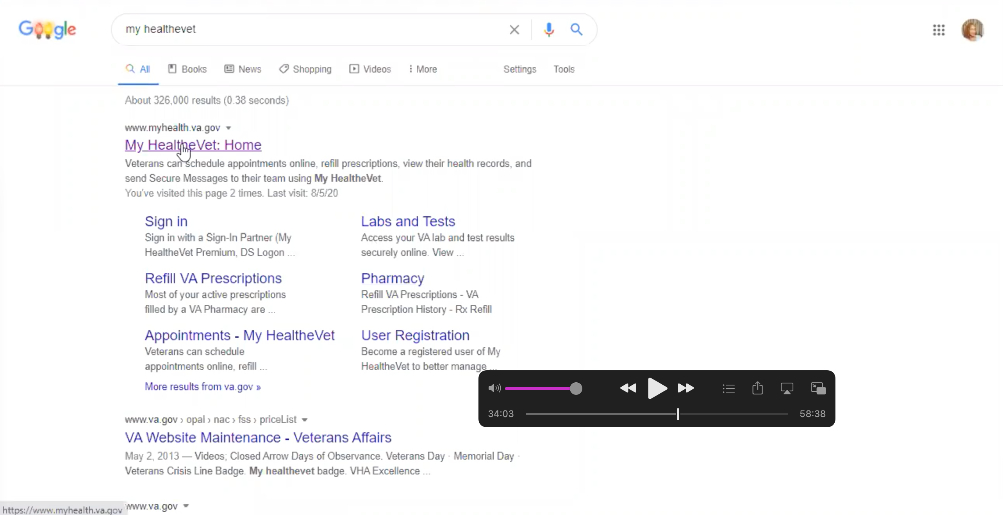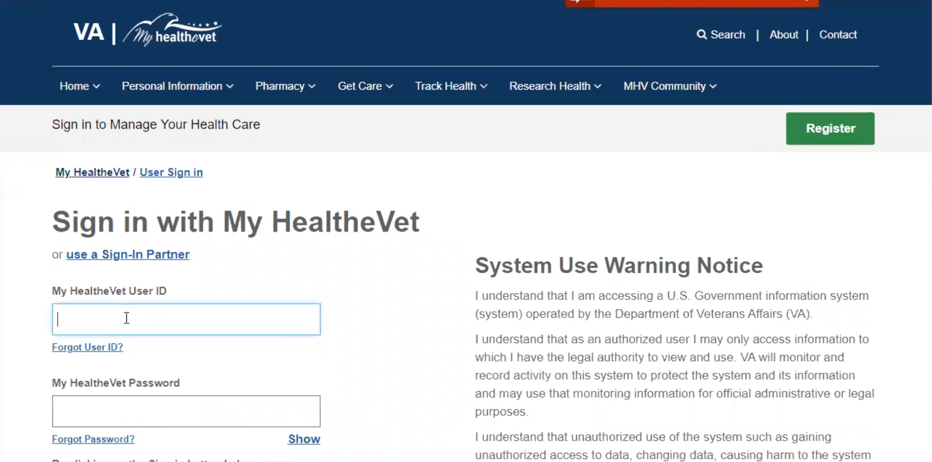

* 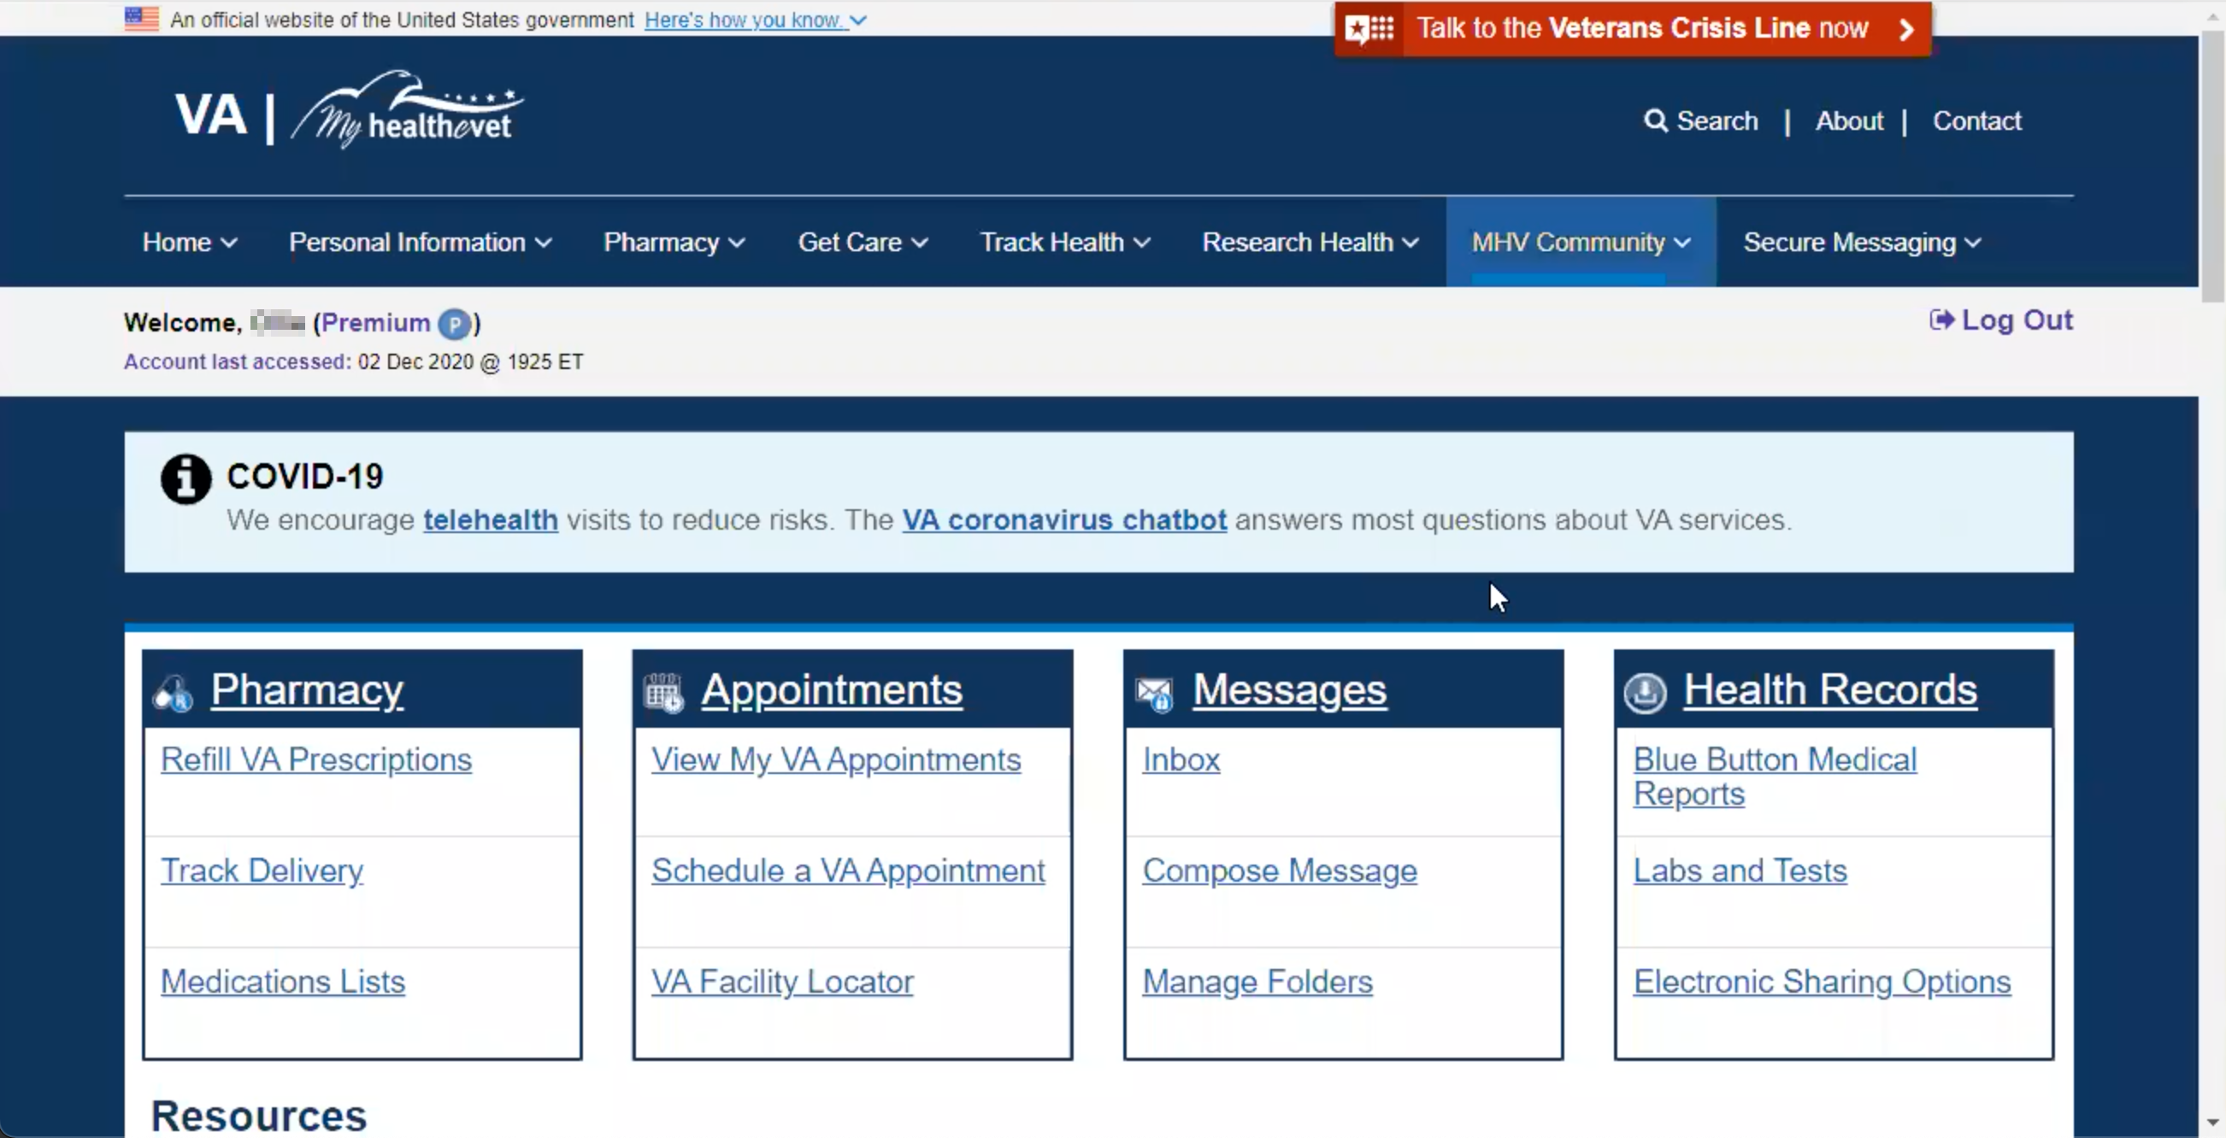
* **How do you know how to login:** I always just go with the one that says myhealthevet. It is easier for me to get to it that way. Once I am here I would go to messages, then I click compose a message. Then once you click it, it brings the screen up and here it has my name, then you put who it goes to, mine would be here, them you come down here to pick the subject, then the subject line and the next box is the message and then once done click send.

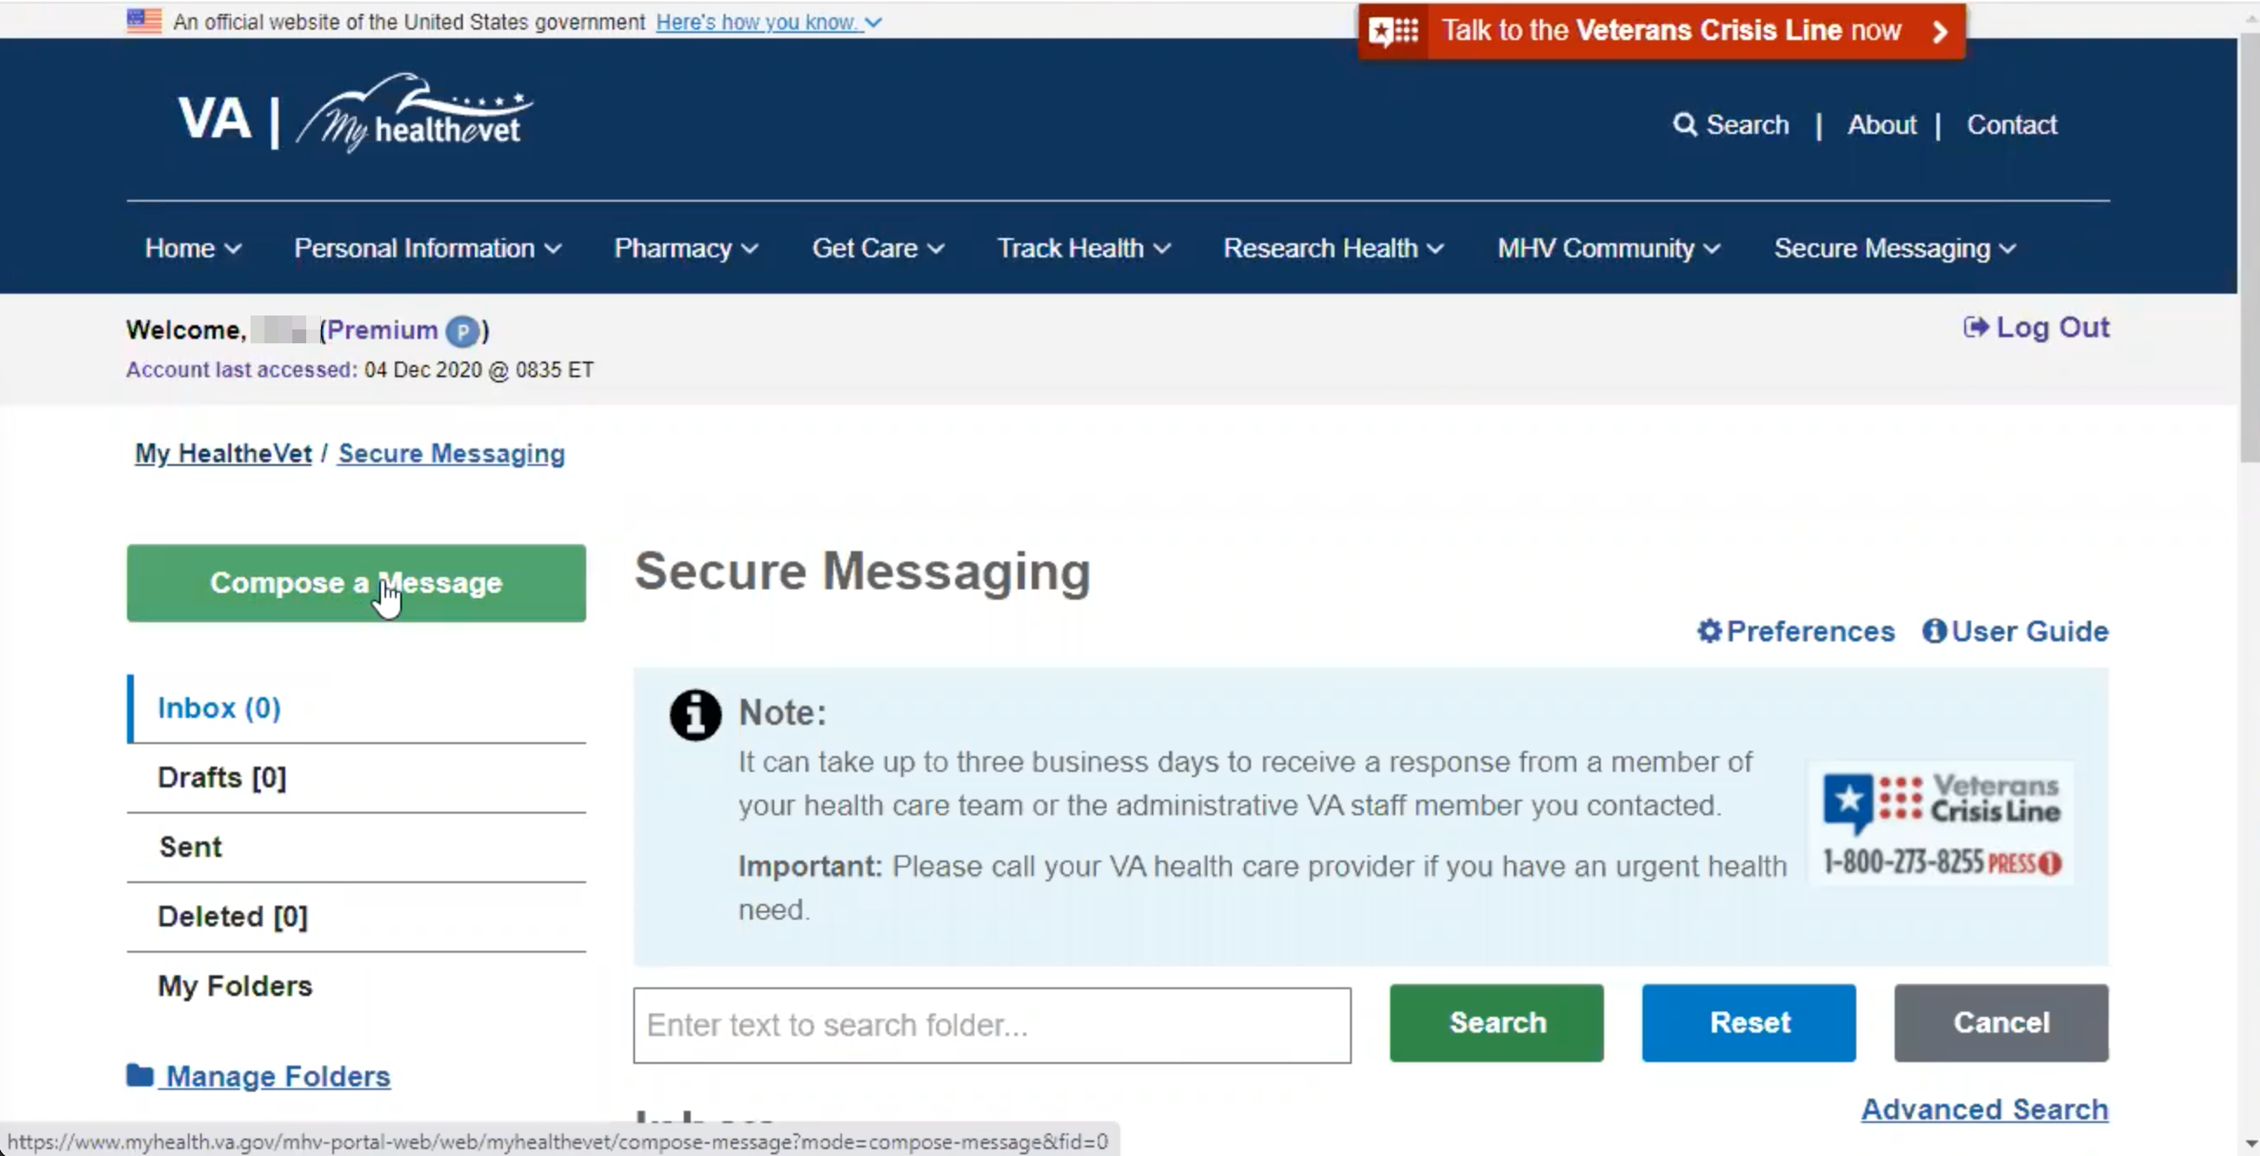

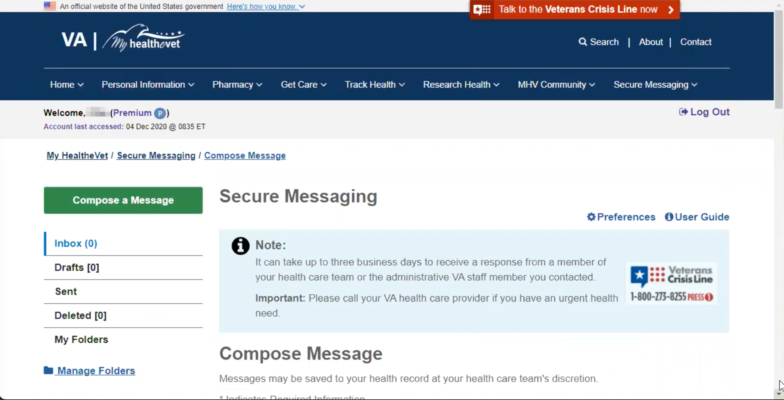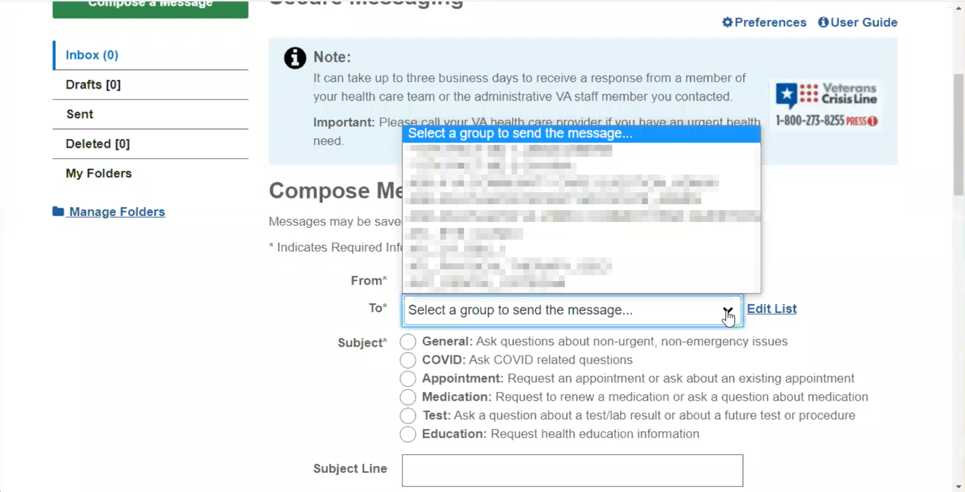

* **You used this last week?**: It was either last week or the week before. I think it was the week before.
* **Do you ever call I=to ask**: I tend to use this because it’s easier because if you try to call, you may be on hold forever and I do not like holding on the phone. Sometimes when the nurse responds they tell me I can call, but... I get quicker response [time with secure messaging].
* **How would you refill a prescription [Veteran] have with the VA**? Let see here. I can use the same process [see notes in italics]. Okay right here under pharmacy, then I would find refill va prescriptions, click on that. I would go to my medication list [clicks] and it would have all of my medications I take and if they are active. If there are no refills left I need to notify the doctor but if there are refills all I need to do is check the ones I want and click send and they mail it to me in the mail.

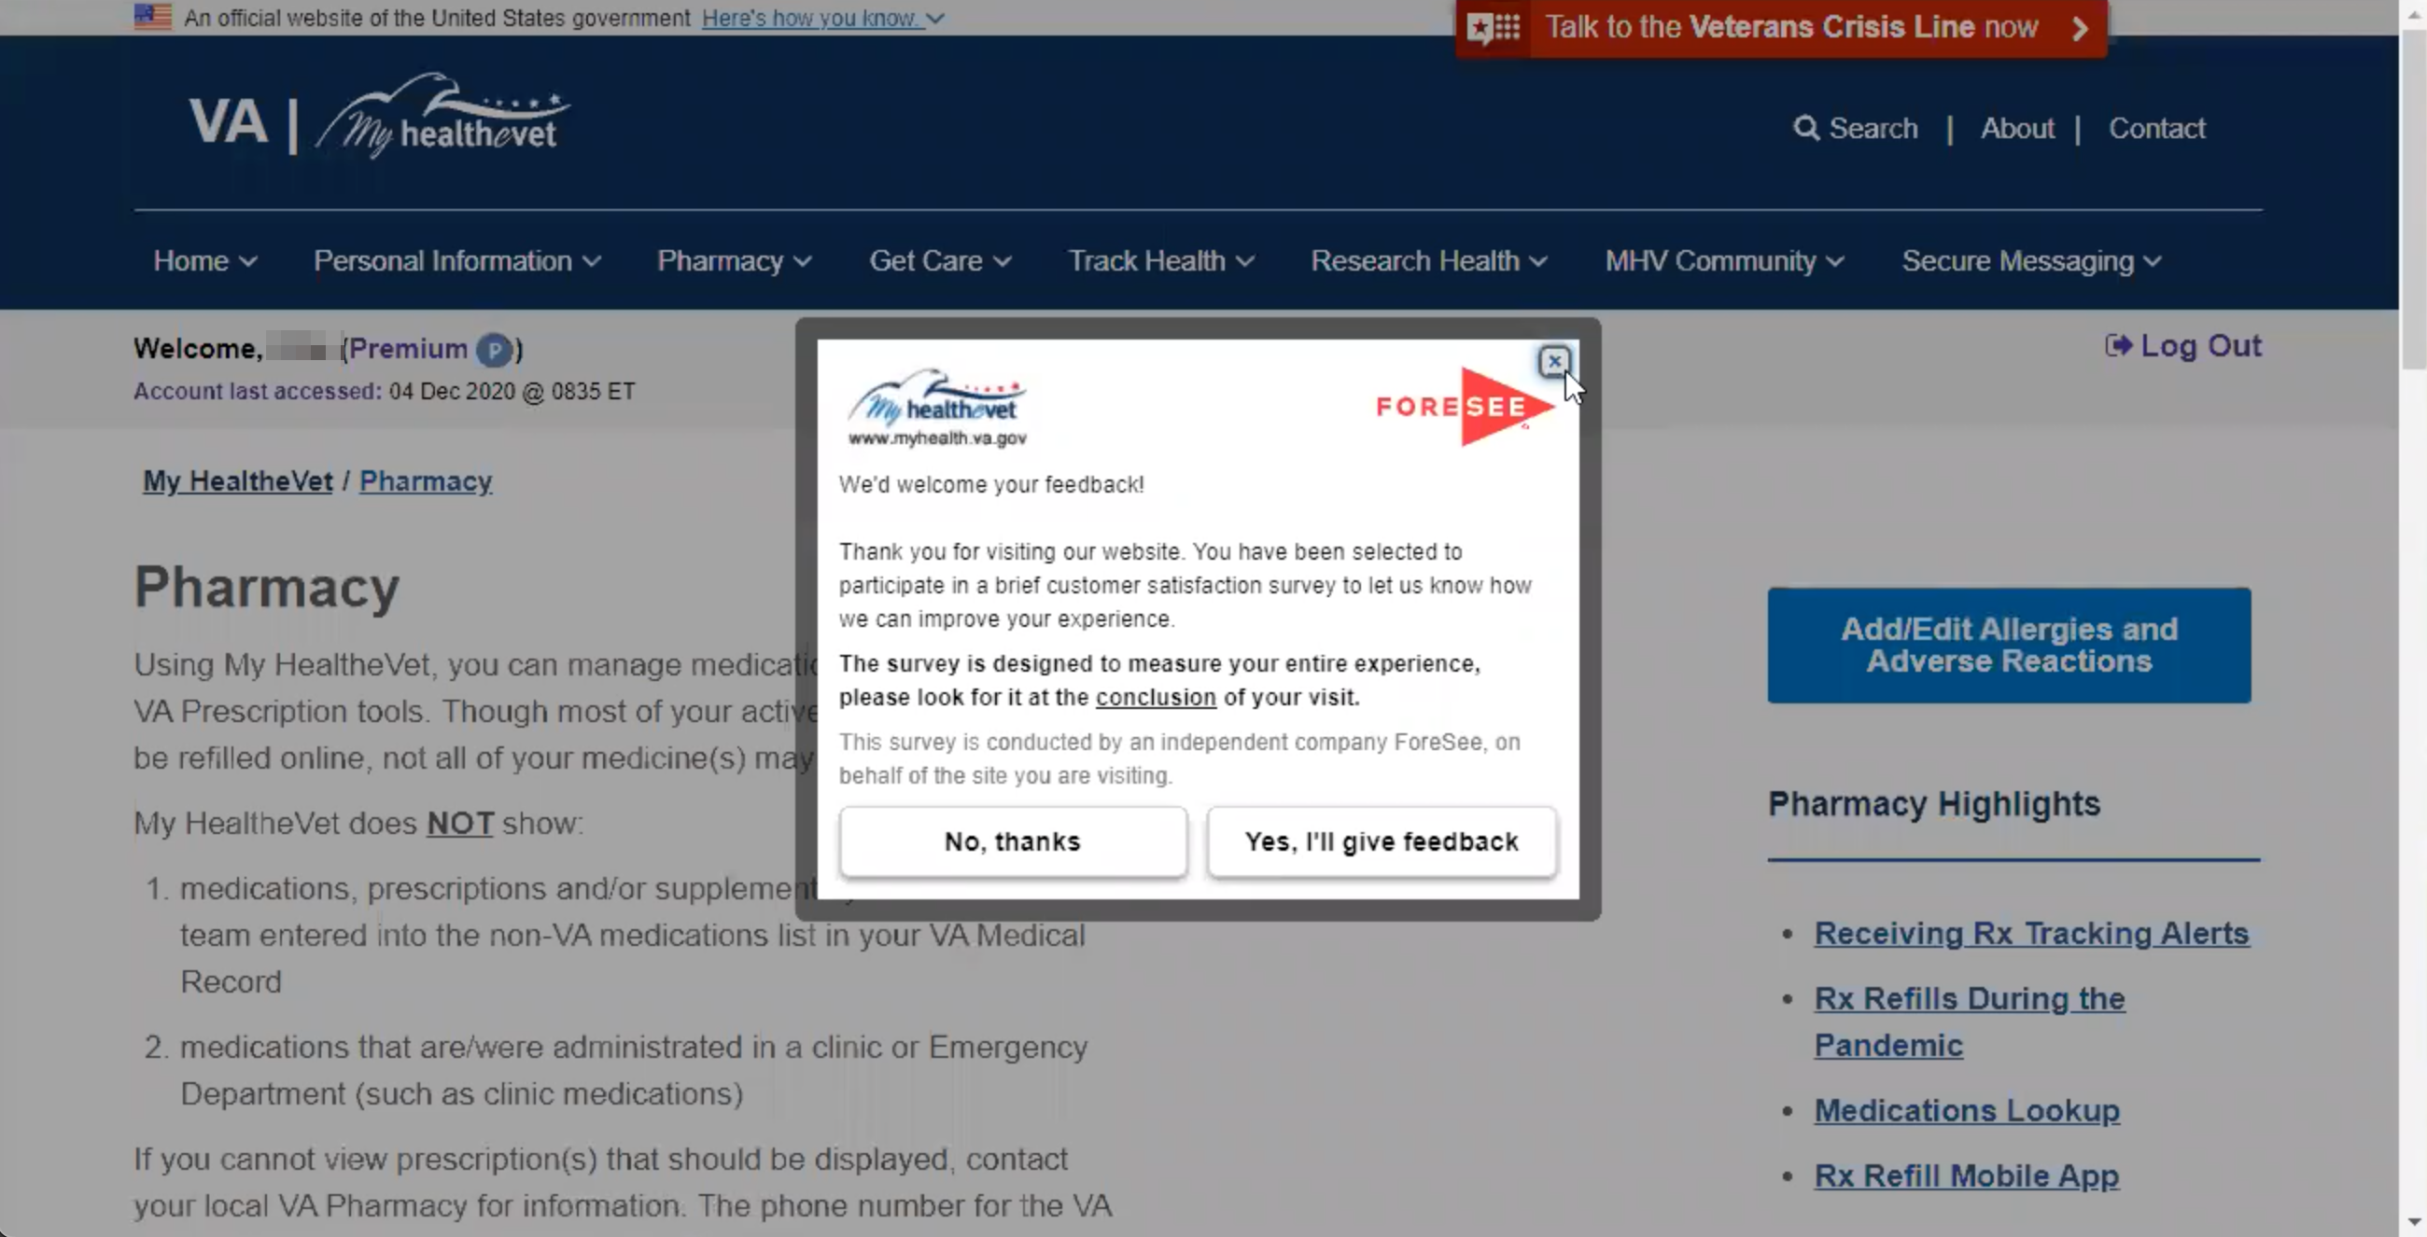

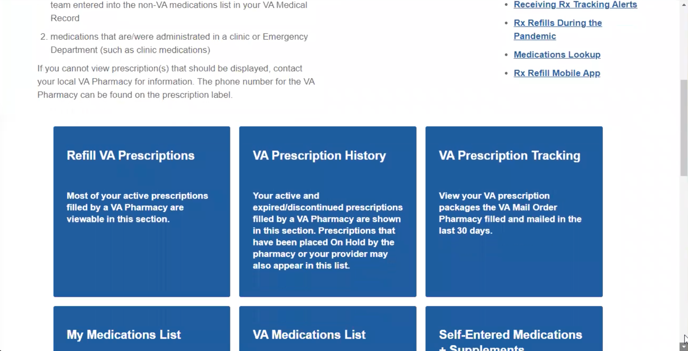

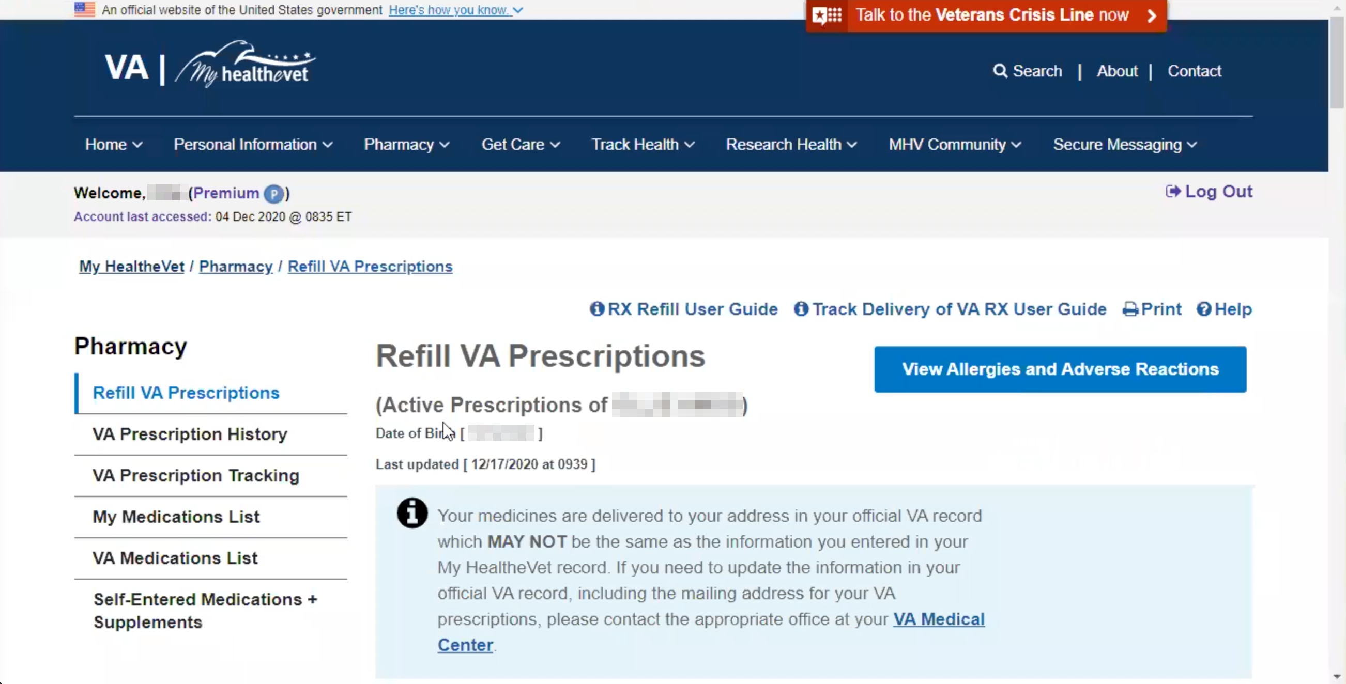

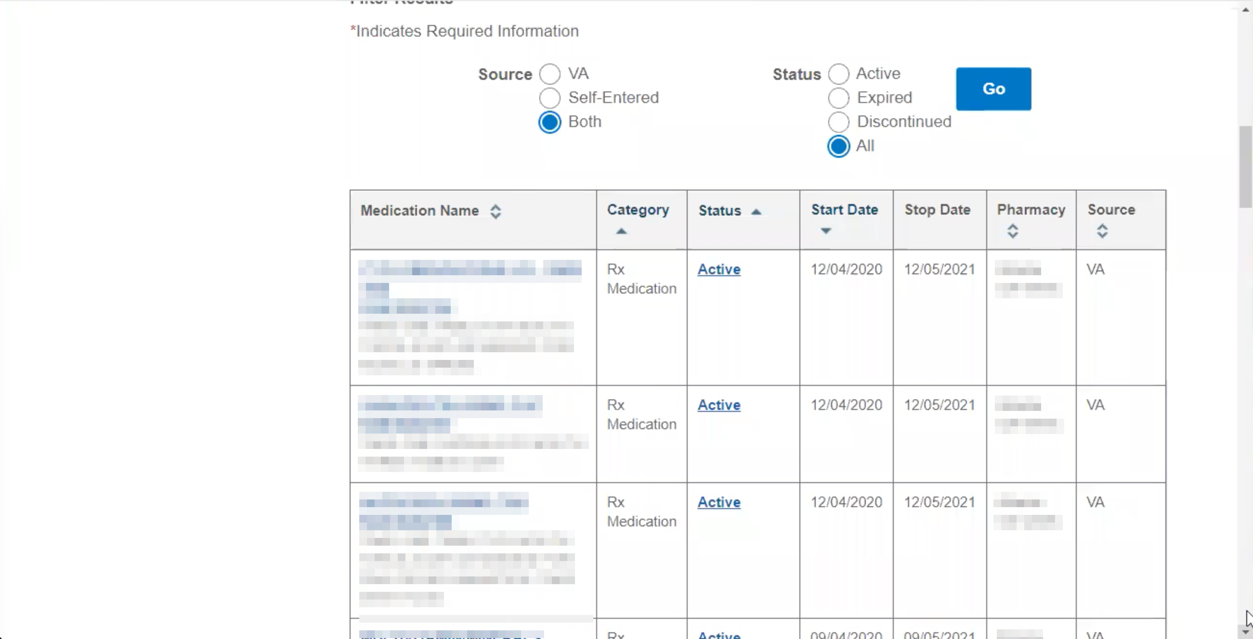

*Couldn’t figure out how to back nav. Accidentally clicked bookmark link in browser toolbar for webmail client. Went back to Google, googled MHV again, got into Pharmacy that way. Global nav by google. Then got foresee survey prompt within perhaps 10 seconds of trying to do something on the site. Then scrolled down past a wall of text to find any calls to action (like refill prescription, which is what this vet was looking for).*

* **For refilling, do you do that online**: Yes. I just go online whenever I need it.
* **How would you look for an appointment with your provider for those regular six-month checkups?**

*Uses MHV main nav to get back to home.*

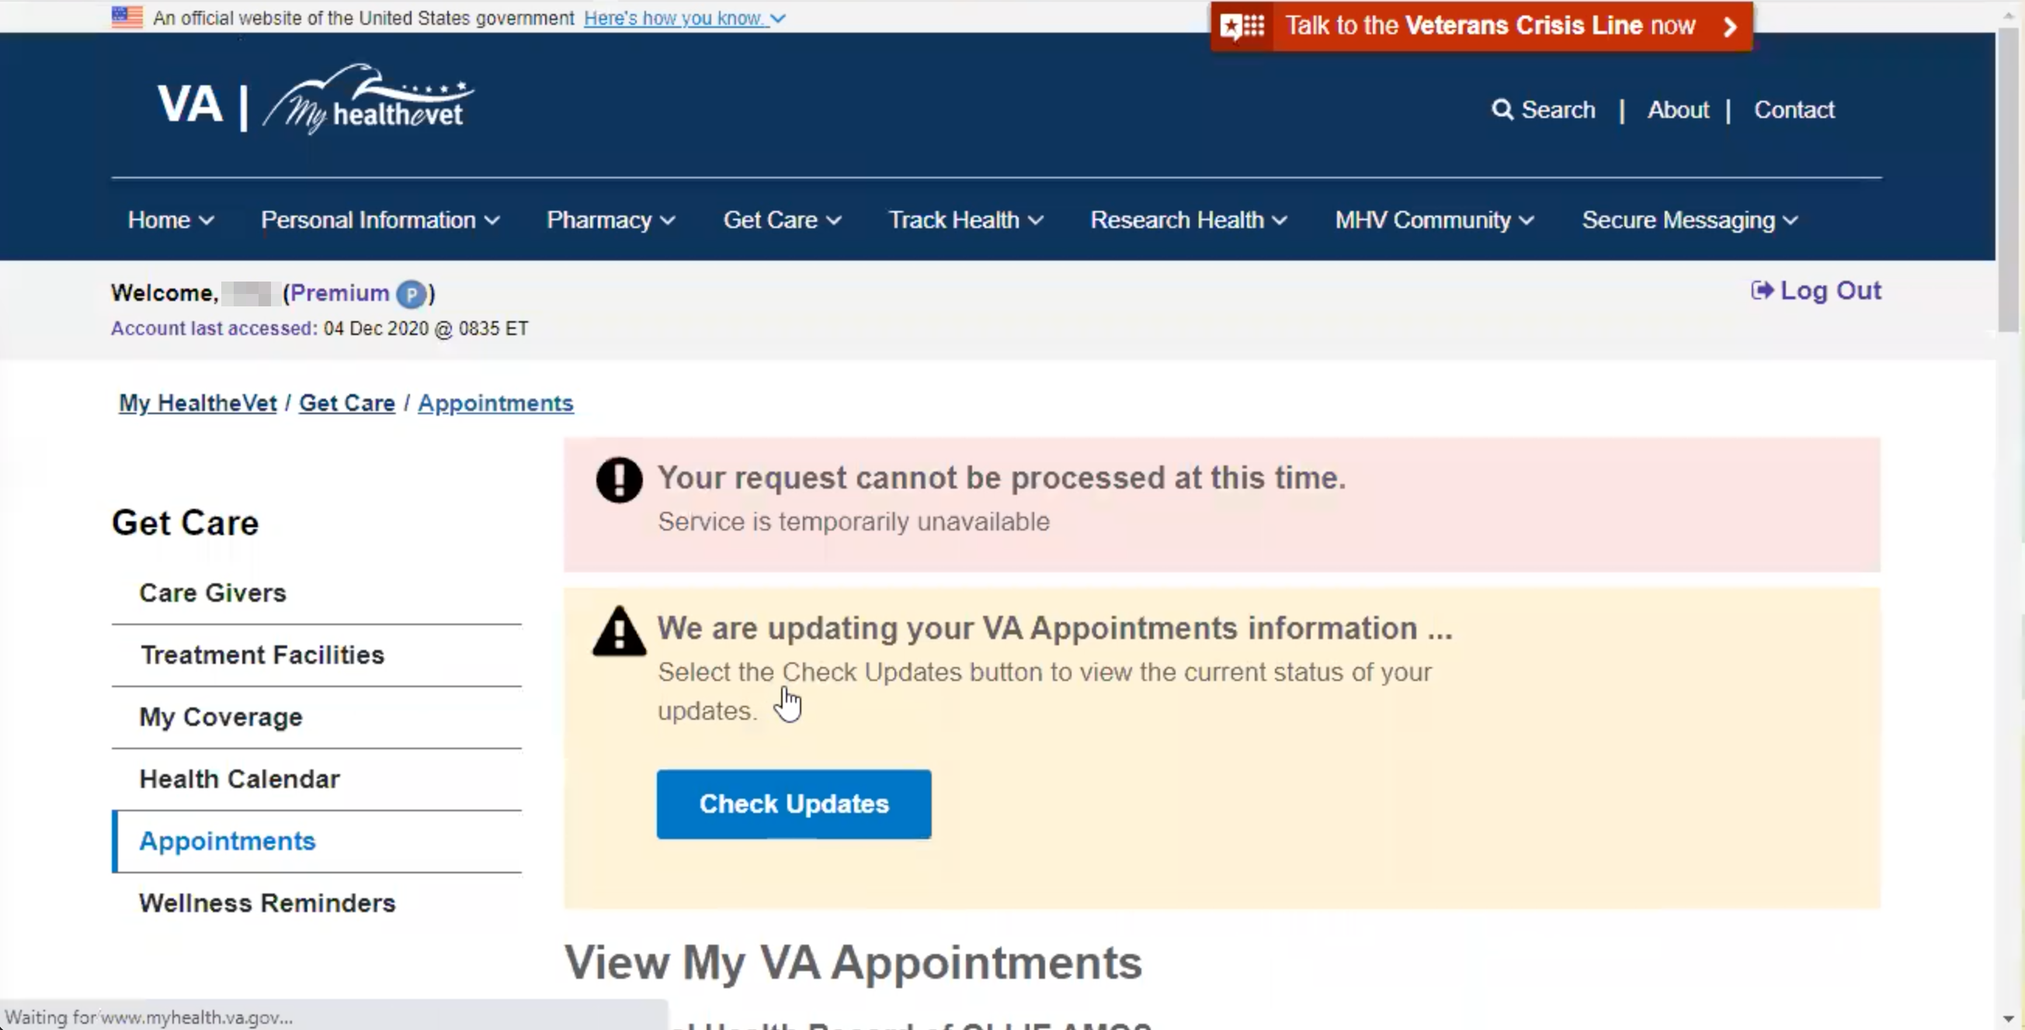

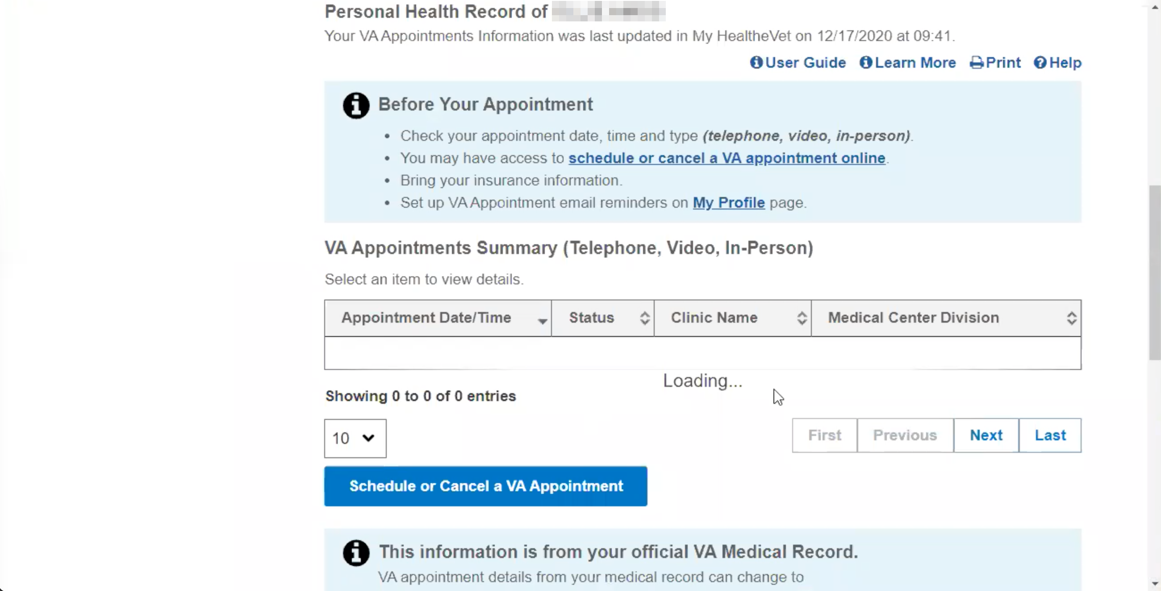

* Go back to the home screen and where it says appointments, you can click on view my appointments and it should bring up... It is saying we are updating your appointments but it should have your appointments listed here. You can also schedule and cancel on this screen. **Have you used that?** No.
* **How do you normally set up an appointment**: Basically I always just send a message.

*Navigates to appointments, but there’s an error message and nothing useful populates onto the page.*

* (If applicable) Or a private provider (dentist, optometrist) outside the VA?
* **Have you ever had to pay a co-pay for a VA health bill**? I don’t think so.
* **How would you request a reimbursement from the VA for traveling to [Veteran's] health care appointments?** Yes. **How?** Before the pandemic, after your appointment they have the kiosk in the VA hospital and you can submit for your reimbursement before you leave. If for some reason you forget, then you have to go online to find the form, filled it and left it with them and they sent it. I forgot one time. I had to go to the [name] clinic and fill it out there and they sent it over. I went to the clinic that was the closest and they provided the paperwork.
* **Have you don’t it online**: No I print it out, I don’t think you can do it online you have to hand write it.
* **How would you update the dependents on [Veteran's] VA benefits**? You would have to do that through DEERS. You may be able to go through them before but I don’t know.
* **What is DEERS**: Let me Google it right quick and tell you what it is. Defense Enrollment Eligibility Reporting System, it is a reference to Tricare.
* **Go there to change it**: Yes, you can do the form then you have to go to the military facility to actually get it done. You have to take documents to show that person is your dependent. **Are you and your husband dependents for each other?** No. We’re our own sponsor.If I weren’t in the military, he would be my sponsor.

**Branding and trust (5 minutes)**

**Now I’d like to ask for your thoughts on My HealtheVet. (Confirm that participant has used My HealtheVet previously. If not, amend questions below to capture their first impressions while looking at a logged in account.)**

1. **How would you describe My HealtheVet to someone who hasn’t used it before?** I would say it is easy to use and helpful when you cannot get your provider on the phone. This is the quickest and easiest way to get to them. Go to Myhealthevet and send them a secure message, you can refill the prescription and get appointments, this is a good site to go to. And it is not hard to use.
2. **What about “VA health care**?” I would say be patient, you’ve got to have patience. There are good and bad things but with time things tend to get better. I think It’s good even though everything needs improvement. I don’t have many complaints with it. I haven’t had major issues with health care, I have gotten pretty good care.
3. **On a scale from 1-5, with 1 being very dissatisfied, and 5 being very satisfied, how satisfied are you with My HealtheVet?** I would say 5, like I said it is easy to use and quicker to do what you need to do. I don’t need to be frustrated by talking to the doctor before I can get [medication]. I can just go to myhealthvet, select the medication I need toto refill it and it is mailed to me.
4. **On a scale from 1-5, with 1 being very low, and 5 being very high, how would you rate your trust in My HealtheVet?** I would say 5. I haven’t had any problems with it.
5. **When you say no probkems, does anything come to mind**: Everything I have used it for has been a success.
6. **Information secure**: yes, I believe it is.
7. **Information accurate and updated**: I think so.
8. **If you have a question about your MHV account or something isn’t working, what do you do?** Probably check the site out to see if there is an area, if you have questions where you can click on like FAQ to see if what I am trying to find out is covered. If it is not then I would see if there is a contact number or email to get the question answered.
9. **Have you ever been in touch with a My HealtheVet Coordinator, that you know of?** No.
10. **How does My HealtheVet compare with other online health tools you’ve used?** I don’t think I have used other online tools. The only other thing is Tricare. I get confused every time I go on tjhere. It tells you to go somewhere and that’s not where you need to be. It is harder to use than my HealtheVet.

**My HealtheVet patient portal (15 minutes)**

Let's take a look at My HealtheVet together.

Moderator will ask participant to share screen if not already, or show logged in My HealtheVet account. **(5 minutes)**

1. **What do you use this website for the most?** Probably to send messages to my provider and send medication refills.
2. **What do you find the most valuable on this website?** Contacting my provider (Secure Messaging). Because most of the time then contact me within a day.
3. **What do you wish this website did that it doesn’t do right now?** Not that I can think of.
4. **Outside of this website, are there other places you go to manage your health care?** Like I said, you can use ebenfits and pull up certain things for your health. My HealtheVet is a part of ebenefits. You can go to myhealthevet from that but it is easier to go straight to my HealtheVet instead of going through ebenefits.
5. **Anything you can do on ebenefits or does it just take you here**: It pulls up... medications and all that. I think there is also a place to look at your medical record, certain things in your medical file.
6. **Can you show us that:**

*Logs out of MHV. Closes tab. Realizes somehow not logged out. Logs out again. That time it works. Googles ebenefits. Hits first result. Clicks to login. Two-page ToS just to auth. DS Logon auth at the bottom.*

Lets hope this works today, this site can be aggravating at times. When I get here I have to agree. Then come down here and do the login. I am trying to remember my password; you have to change it ever so often. [long pause] I can’t remember my password. I wrote over it. Now I am guessing. Alright so here if you want to apply you can do that here (reading list) you can choose what you want to go to. Then down here you can apply , manage the benefits here (reading list), Then manage the health (reading page).

1. You can see the medications, and medical records here: yes, right here is va prescriptions. You are here then click refill va prescriptions. *[redirected to MHV*] You can even track the delivery if they say it was sent. Right here you can see just like it did in my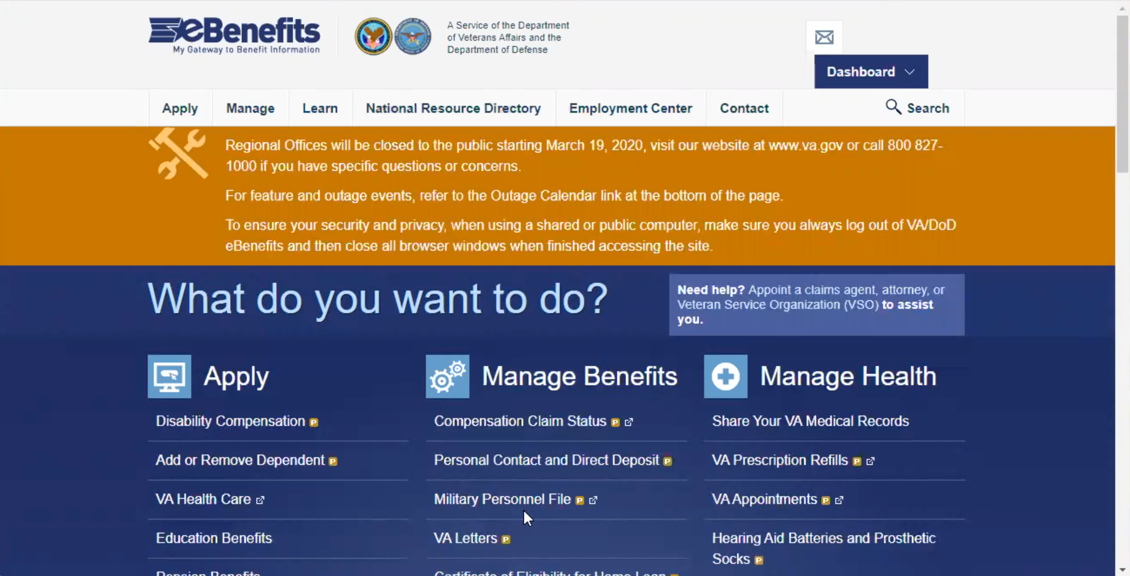HealtheVet, you have the medications listed and you can click the box to have it refilled.

*Participant did not notice that they wound up back on MHV. This is a theme IMO. IA inconsistencies are glossed over. What matter are usabilty, discoverability and SSO.*

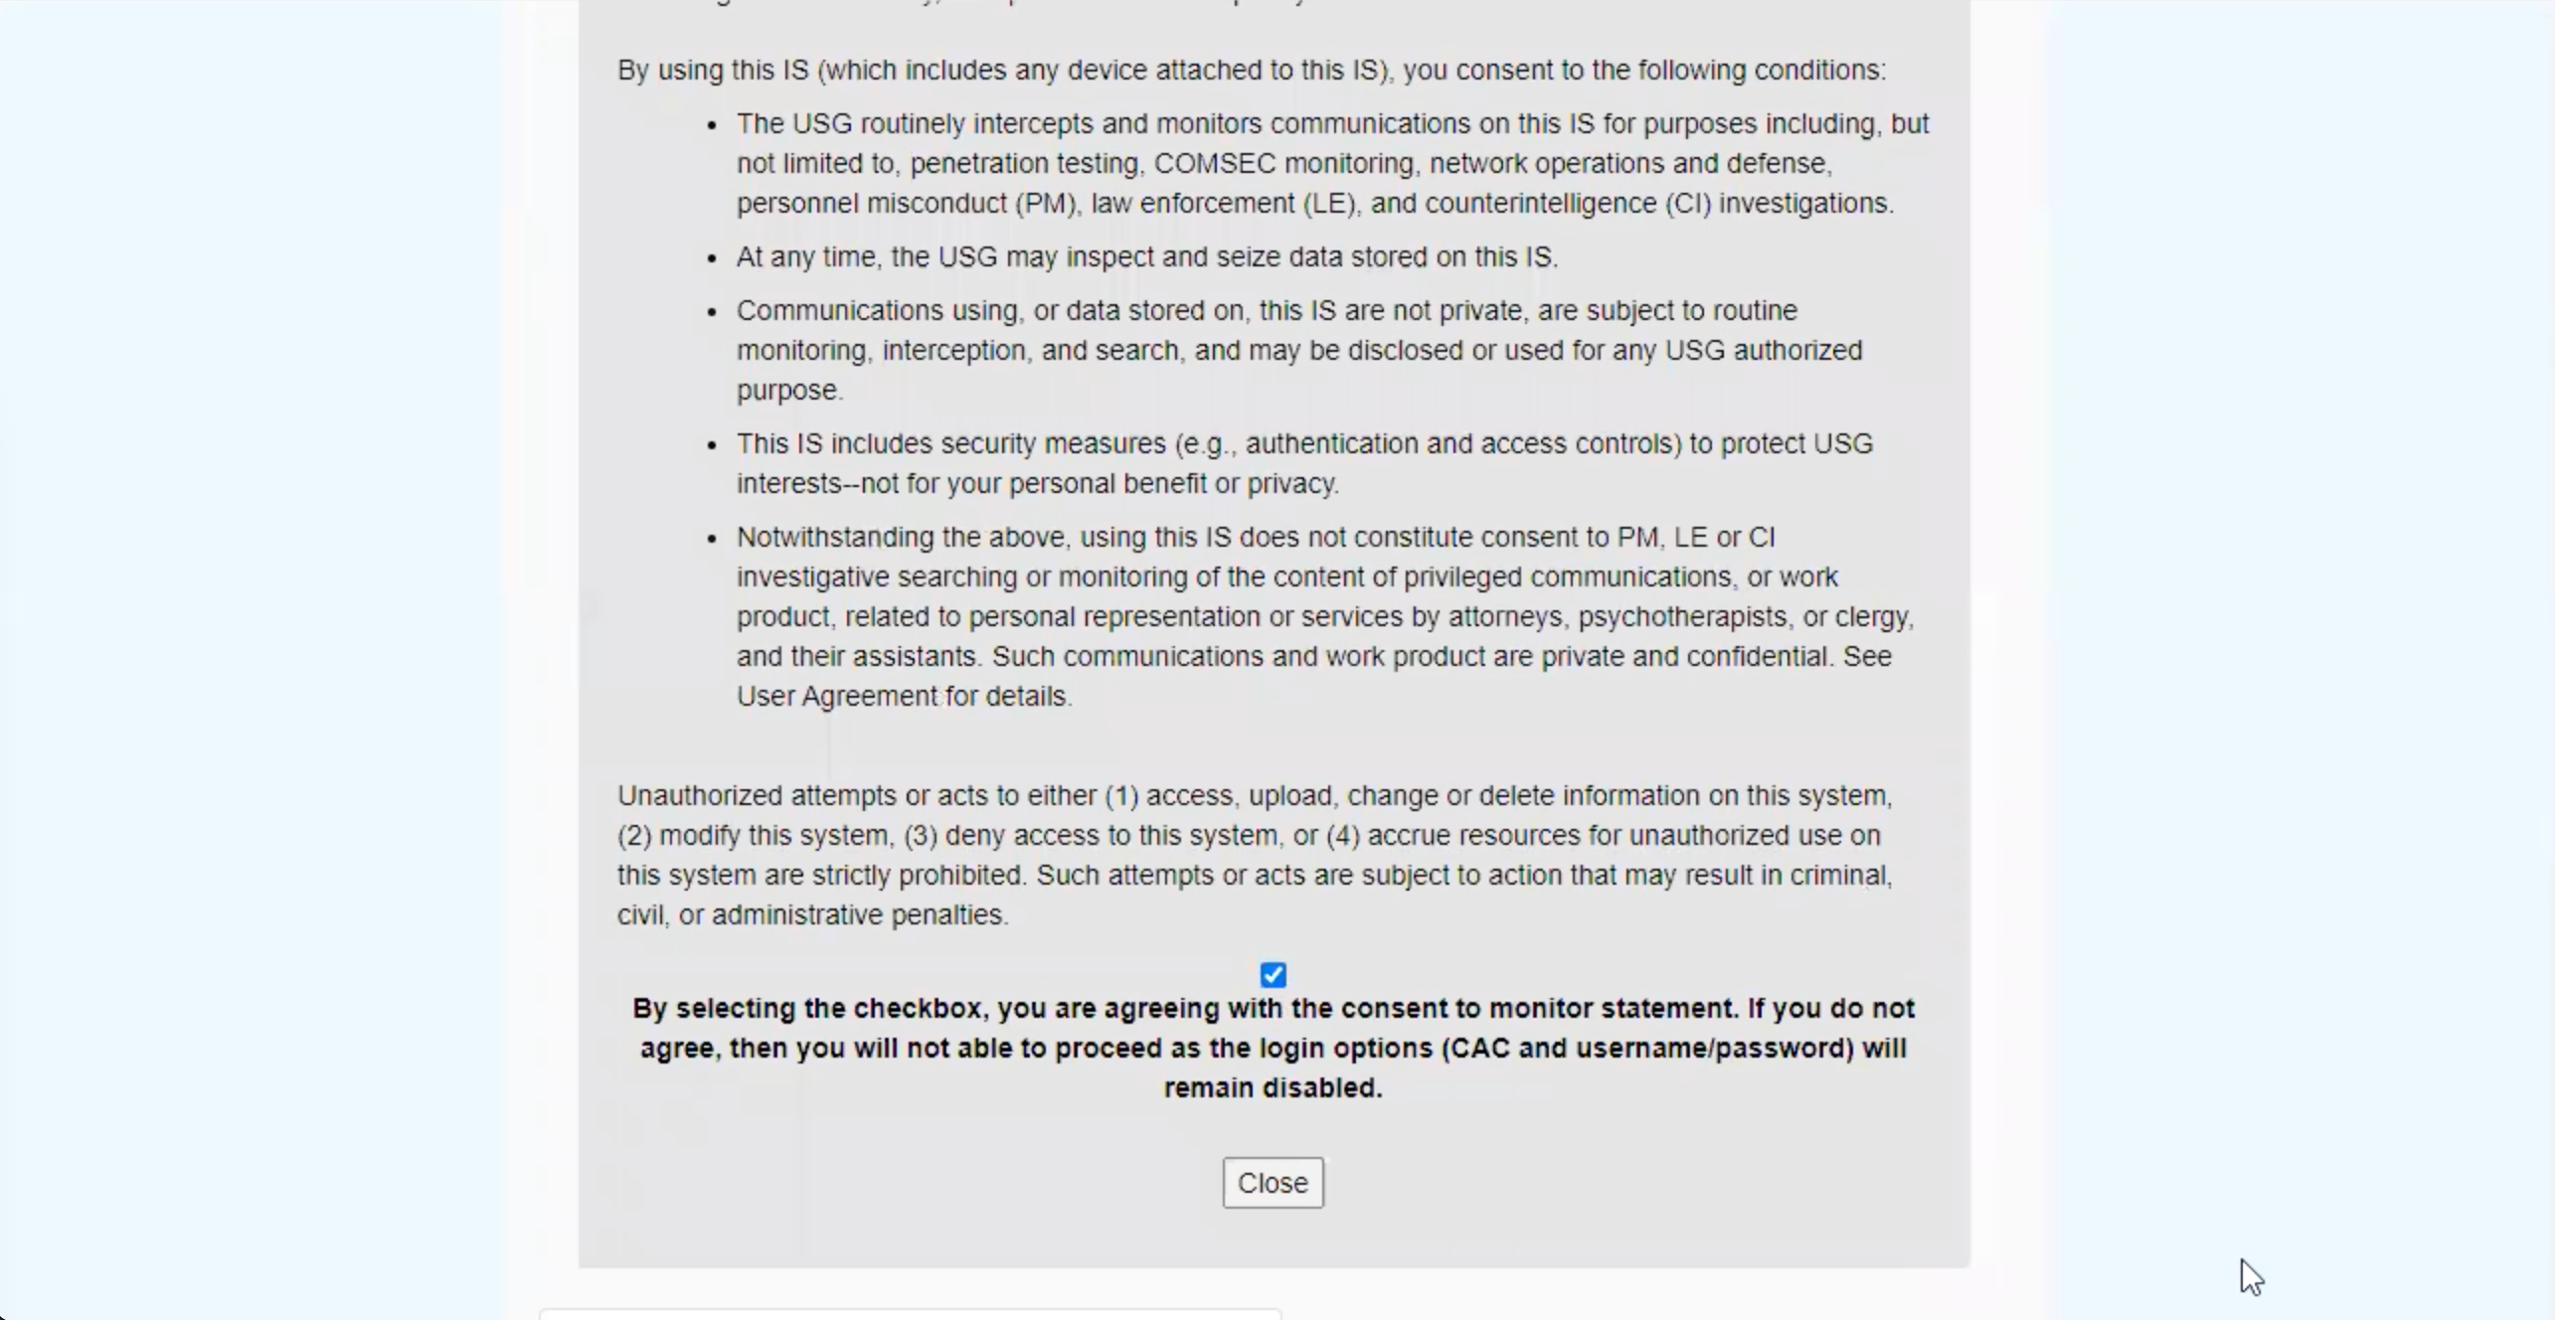**Thank you and closing (2 minutes)**

Feedback:

Well we really appreciate you taking the time to share your thoughts with us today. Your feedback is so helpful to us as we continue to work on the site and make sure it really works for Veterans.

Lastly, do you know any other Veterans, caregivers, or service members who might be willing to participate in a future user research session? If Yes: Thank you! I'll have our team send you an email with a little blurb that you can pass along.

Great, well thank you so much again, and enjoy the rest of your day!